**PROJECT REPORT**

**ON**

**GRAPHICS DESIGN**

**COURSE CODE: SWD327**

**COUSE TITLE: MANDATORY SKILL ACQUISITION**

**WRITTEN BY:**

**OKE UBAN OSONWA**

**2023/HND/36637/CS**

**COMPUTER SCIENCE**

**SUBMITTED TO:**

**MR. AUGUSTINE ONUORA (COURSE LECTURER)**

**COMPUTER SCIENCE DEPARTMENT**

**SCHOOL OF SCIENCE**

**AKANU IBIAM FEDERAL POLYTECHNIC UNWANA, AFIKPO, EBONYI STATE.**

**AUGUST 16, 2024**

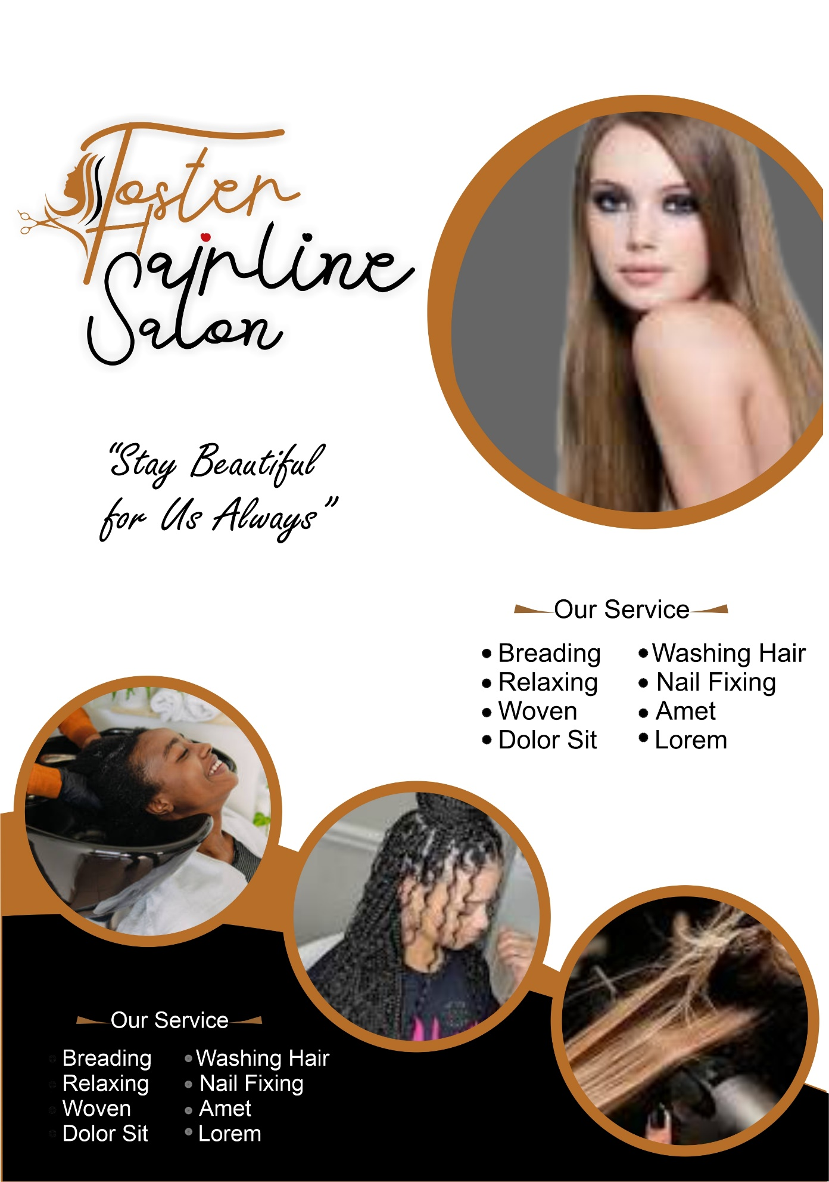

* **INTRODUCTION**

This report presents an overview of the project undertaken as part of the Mandatory Skills Acquisition course. The project involved the GRAPHICS DESIGN using CorelDRAW. The course provided the necessary foundation in GRAPHICS DESIGN, culminating in the creation of this practical aspect.

* **COURSE OVERVIEW**

The Graphic Design course offered a comprehensive introduction to different creative tools which covers various design. Through learning and exercises on this course, the course equipped me with the skills to create and design different graphics work like:. **FOSTER HAIRLINE SALON FLEX**

* **CERTIFICATION ACHIEVEMENT**

During the course, I was been able to obtained certificate to validate acquired knowledge and skill on Graphics Design from GCF Global. This certification confirmed proficiency in graphics design.

**PROJECT DESCRIPTION: GRAPHICS DESIGN WITH CORELDRAW**

This document provides a detailed description of the promotional design created for Foster Hairline Salon using CorelDRAW. The design aims to attract potential customers by showcasing the salon's services and emphasizing beauty.

**DESIGN ELEMENTS**

1. **Logo and Tagline**

* **Logo:** The top section features the stylized text logo "Foster Hairline Salon.
* **Tagline:** Below the logo, the tagline "Stay Beautiful for us Always" is prominently displayed.

**2. Main Visual**

* **Central Image:** A circular frame with an obscured face of a person with long hair, highlighting a hairstyle offered by the salon.

**3. Service Listings**

* **Sections:** Two sections titled "Our Service" list the services provided by the salon.
* **Services Include:** Braiding, Washing Hair, Nail Fixing, Woven Sit, Relaxing, Amet, Dolor Sit, Lorem

**4. Additional Visuals**

* Smaller Circular Images: Three smaller circular images show different individuals:

- One appears to be getting their hair braided.

- Another seems to have their hair washed or treated.

- The third is too obscured to describe accurately.

**5. Color Scheme**

- The design uses shades of pink and brown to create an inviting and elegant look.

**Tools and Techniques Used**

1. **CorelDRAW Tools**

**- Text Tool:** Used for creating the logo and tagline.

**- Ellipse Tool:** Used to create the circular frames.

**- Shape Tool:** Used to adjust the shapes and frames.

**- Fill Tool:** Applied to add colors to different elements.

**- Image Import:** Imported images for the main visual and smaller circular images.

**2. Design Techniques**

* **Layering:** Different elements are placed on separate layers for easy editing.
* **Alignment:** Ensured all elements are properly aligned for a balanced look.
* **Color Harmony:** Used a consistent color scheme to maintain visual harmony.
* **CHALLENGES AND SOLUTIONS**

The challenged I faced during the learning process was Poor network and inadequate availability of light which was a big constraint. And this challenge was been tacked by meeting friends and colleagues who were also inclined with graphics design.

* **CONCLUSION**

The development of graphics design was the best learning experience, the project really applied the knowledge and skills acquired during the Mandatory Skill Acquisition course. The system demonstrates to potential of graphics design.

For reference purposes, kindly visit **https://github.com/pregold994/my-graphics-work**